ASSIGNMENT NO.9: Data Retrieval, Functions, and Joins in MySQL

Student Name | Anushka Pachpute | Roll Number | 20971
Batch | SY. BSc Data Science | Topic | WB(Assignment-9)

Q1) Create a MySQL database named CollegeDB and create two tables: OnlineEnrollment and OfflineEnrollment.
OnlineEnrollment Table

Column Name | Data Type | Constraint
StudentID | INT | PRIMARY KEY
StudentName | VARCHAR(50) | NOT NULL
Course | VARCHAR(30)
City | VARCHAR(30)
Marks | INT
OfflineEnrollment Table

Column Name | Data Type | Constraint
StudentID | INT | PRIMARY KEY
StudentName | VARCHAR(50) | NOT NULL
Course | VARCHAR(30)

Column Name | Data Type | Constraint
City | VARCHAR(30)
Marks | INT
Insert at least 6 records into each table. Some records should be common in both tables.

QUERY:

CREATE DATABASE CollegeDB;
USE CollegeDB;

CREATE TABLE OnlineEnrollment (
StudentID INT PRIMARY KEY,
StudentName VARCHAR(50) NOT NULL,
Course VARCHAR(30),
City VARCHAR(30),
Marks INT
);

CREATE TABLE OfflineEnrollment (
StudentID INT PRIMARY KEY,
StudentName VARCHAR(50) NOT NULL,
Course VARCHAR(30),
City VARCHAR(30),
Marks INT
);

INSERT INTO OnlineEnrollment VALUES
(1, 'Rahul Sharma', 'BSc IT', 'Mumbai', 78),
(2, 'Priya Patil', 'BCA', 'Pune', 85),
(3, 'Aman Verma', 'BSc CS', 'Nashik', 67),
(4, 'Sneha Joshi', 'BSc IT', 'Mumbai', 91),
(5, 'Karan Mehta', 'BCA', 'Thane', 74),
(6, 'Neha Shah', 'BSc IT', 'Pune', 88);

INSERT INTO OfflineEnrollment VALUES
(4, 'Sneha Joshi', 'BSc IT', 'Mumbai', 91),
(5, 'Karan Mehta', 'BCA', 'Thane', 74),
(7, 'Rohan Desai', 'BSc CS', 'Mumbai', 69),
(8, 'Meera Kulkarni', 'BCA', 'Nashik', 82),
(9, 'Arjun Nair', 'BSc IT', 'Thane', 59),
(10, 'Divya More', 'BCA', 'Mumbai', 93);

OUTPUT:

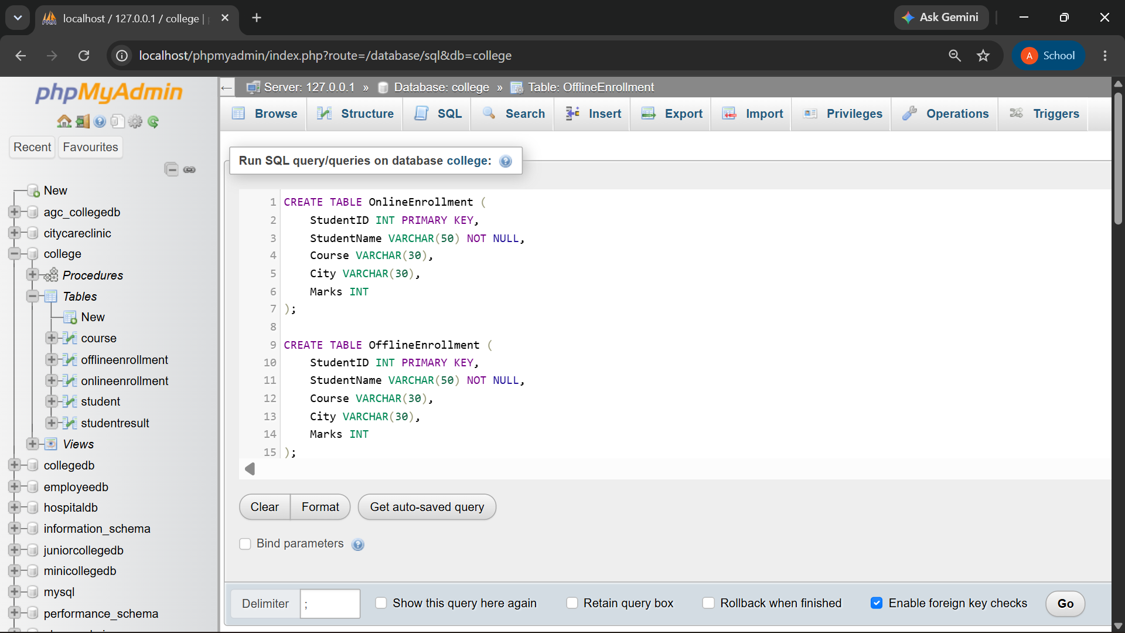
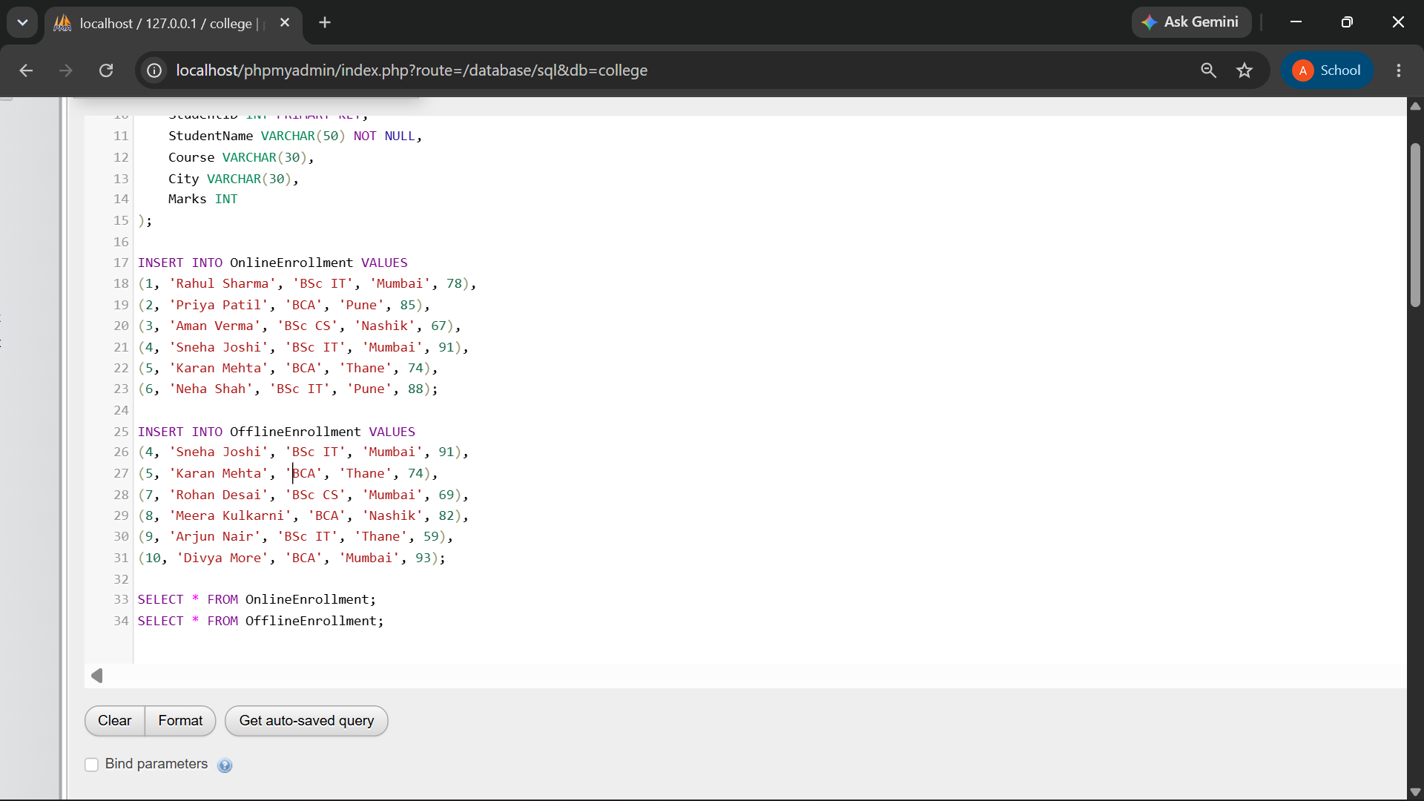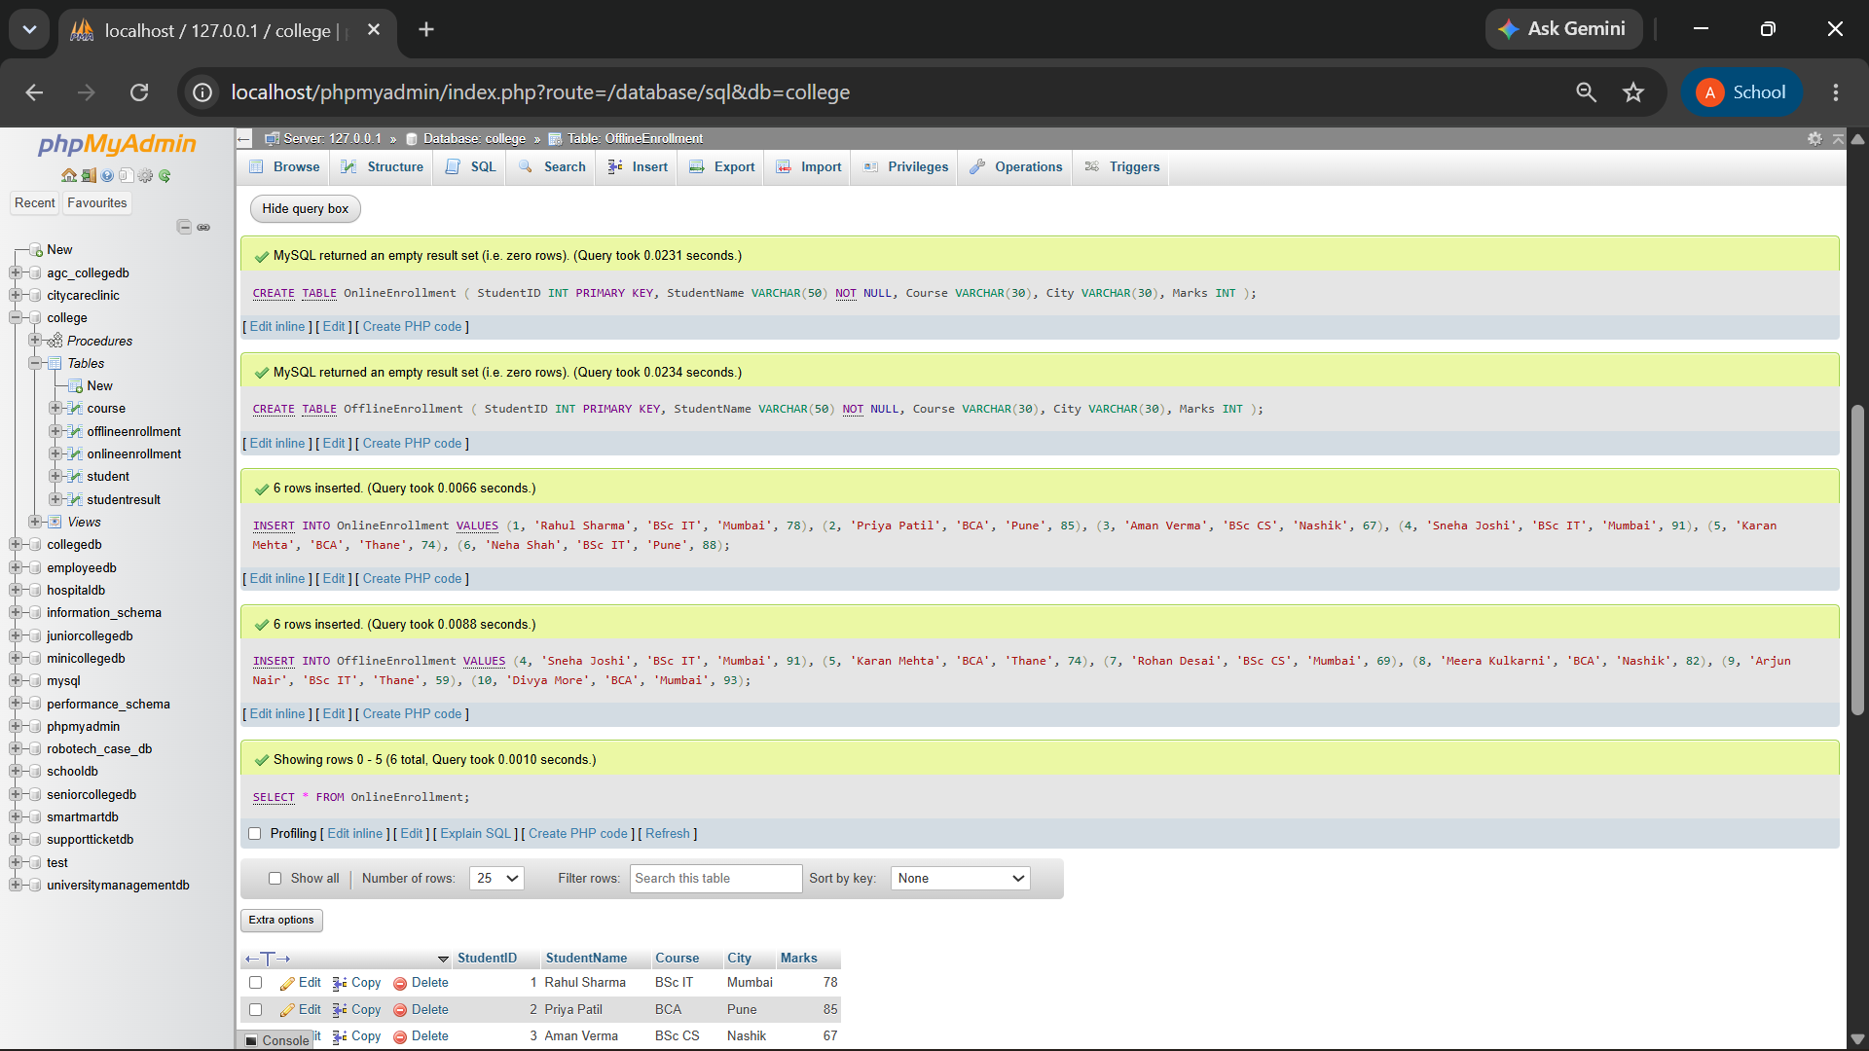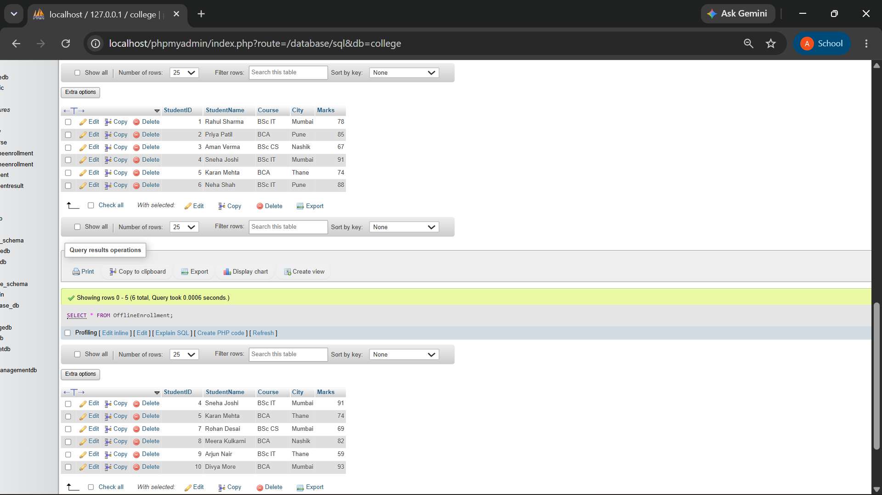

2) Write a MySQL query using UNION to display all unique students from both OnlineEnrollment and OfflineEnrollment.
The output should contain:
Column
StudentID
StudentName
Course
City
Marks

QUERY:
SELECT StudentID, StudentName, Course, City, Marks FROM OnlineEnrollment
UNION
SELECT StudentID, StudentName, Course, City, Marks FROM OfflineEnrollment;

OUTPUT:

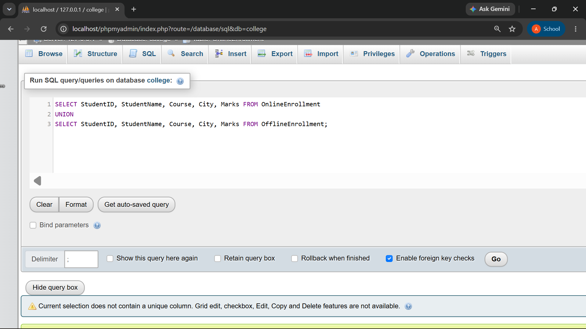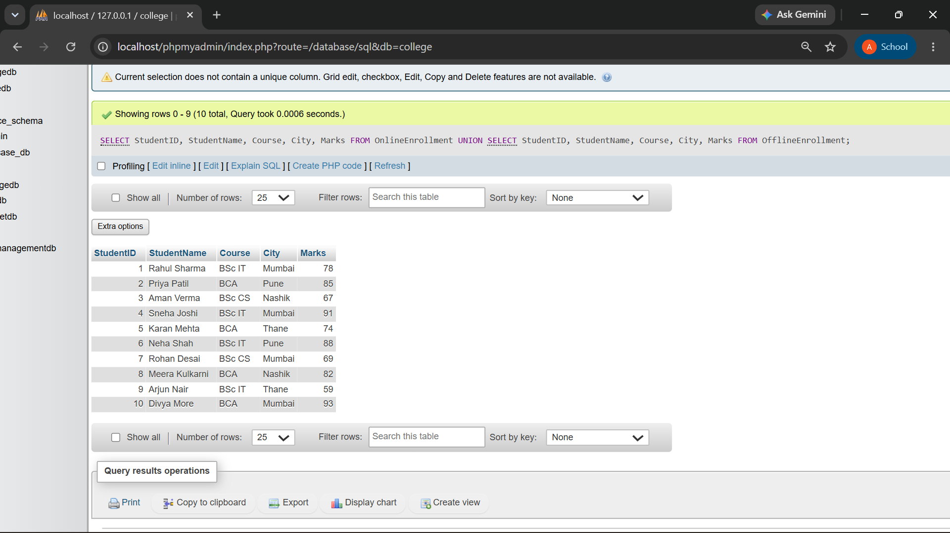

Q3) Write a MySQL query using UNION ALL to combine records from both tables while keeping duplicate records.
Also write one line explaining the difference between UNION and UNION ALL.

QUERY:

SELECT StudentID, StudentName, Course FROM OnlineEnrollment
UNION ALL
SELECT StudentID, StudentName, Course FROM OfflineEnrollment;

OUTPUT:

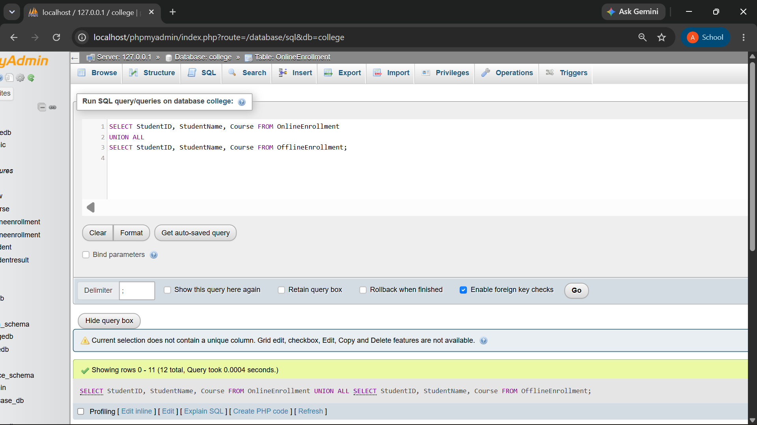
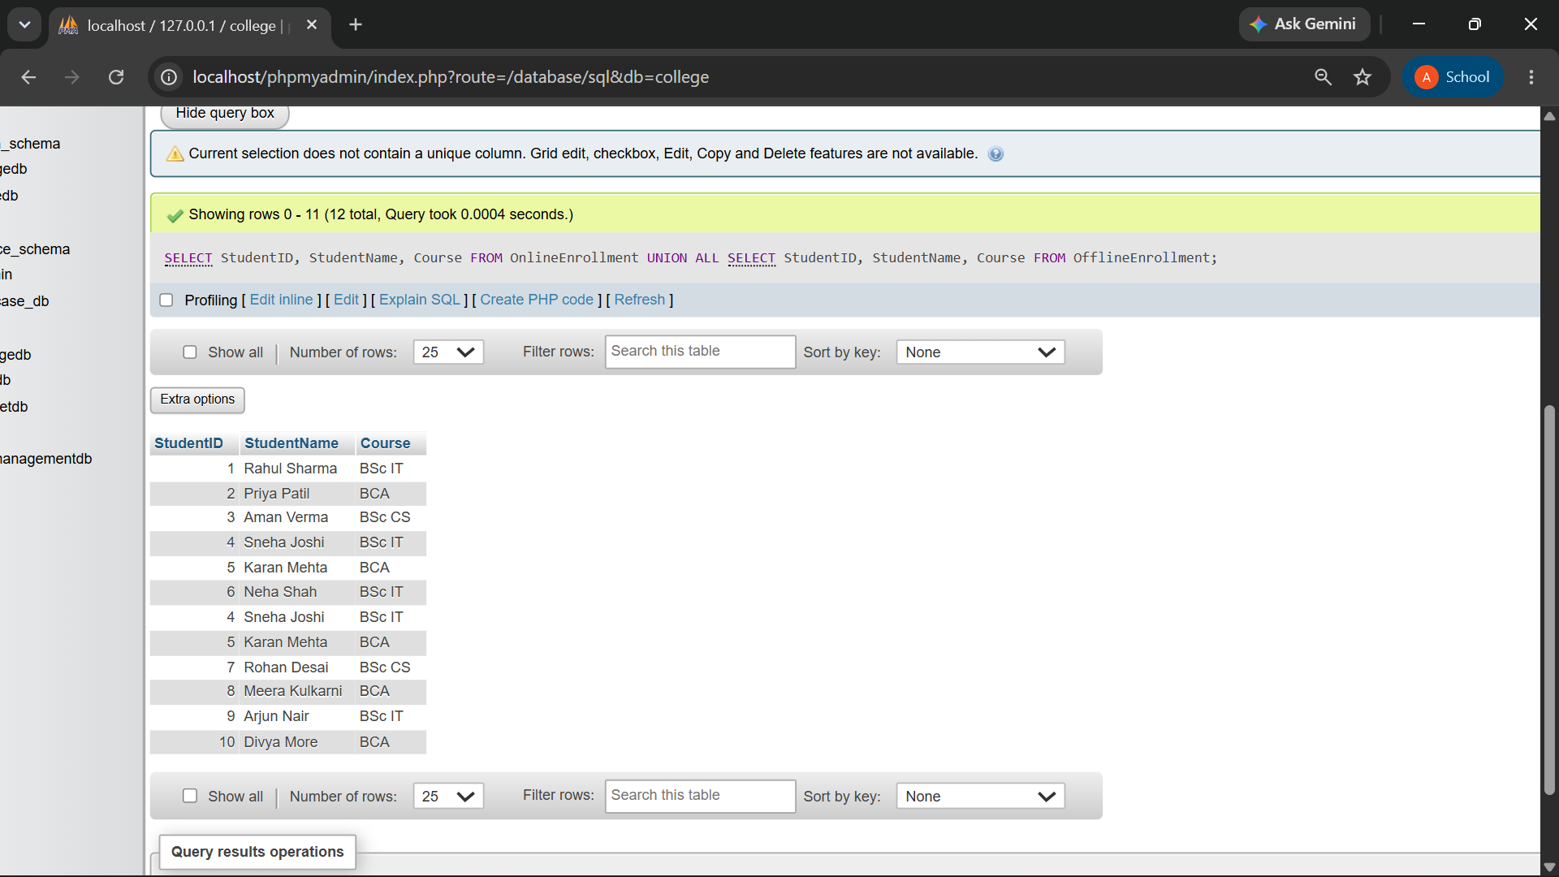
- UNION → Combines results and removes duplicate records.
- UNION ALL → Combines results and keeps duplicate records.

Q4) Write a MySQL query using INTERSECT to display students who are present in both online and offline enrollment tables.
The output should contain:
Column
StudentID
StudentName
Course
City
Marks

QUERY:
SELECT StudentID, StudentName, Course, City, Marks FROM OnlineEnrollment
INTERSECT
(SELECT StudentID, StudentName, Course, City, Marks FROM OfflineEnrollment);

OUTPUT:

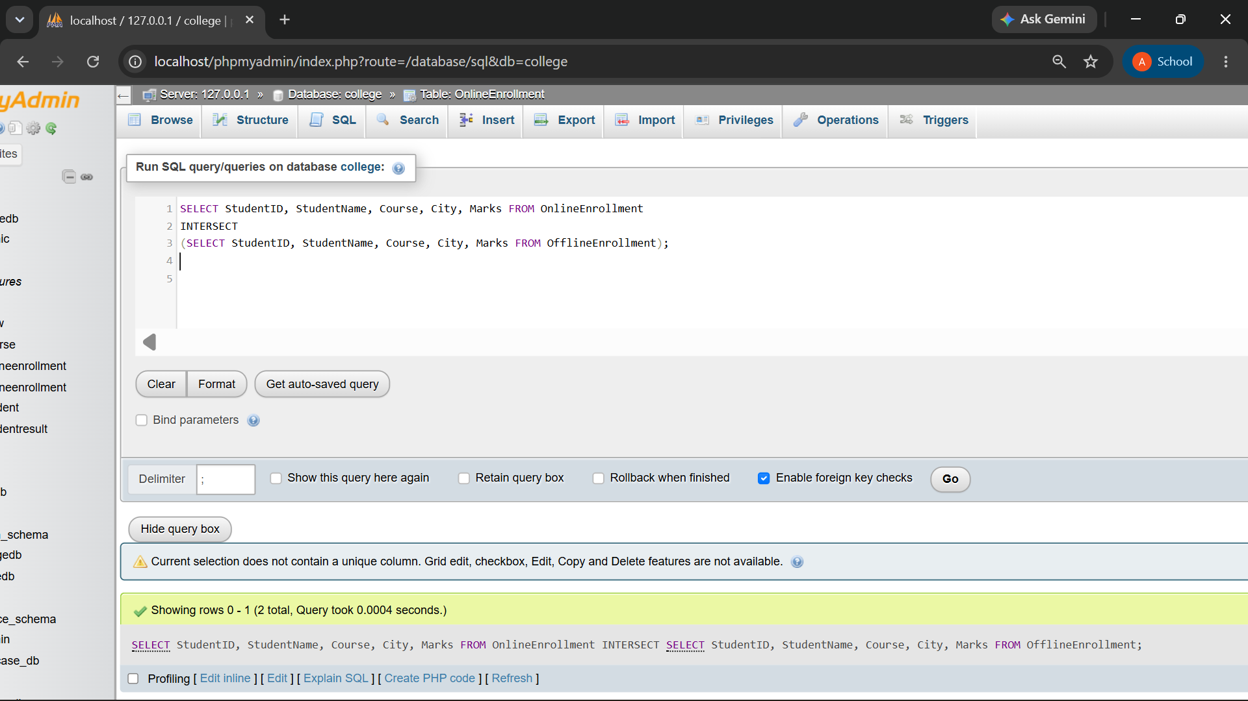
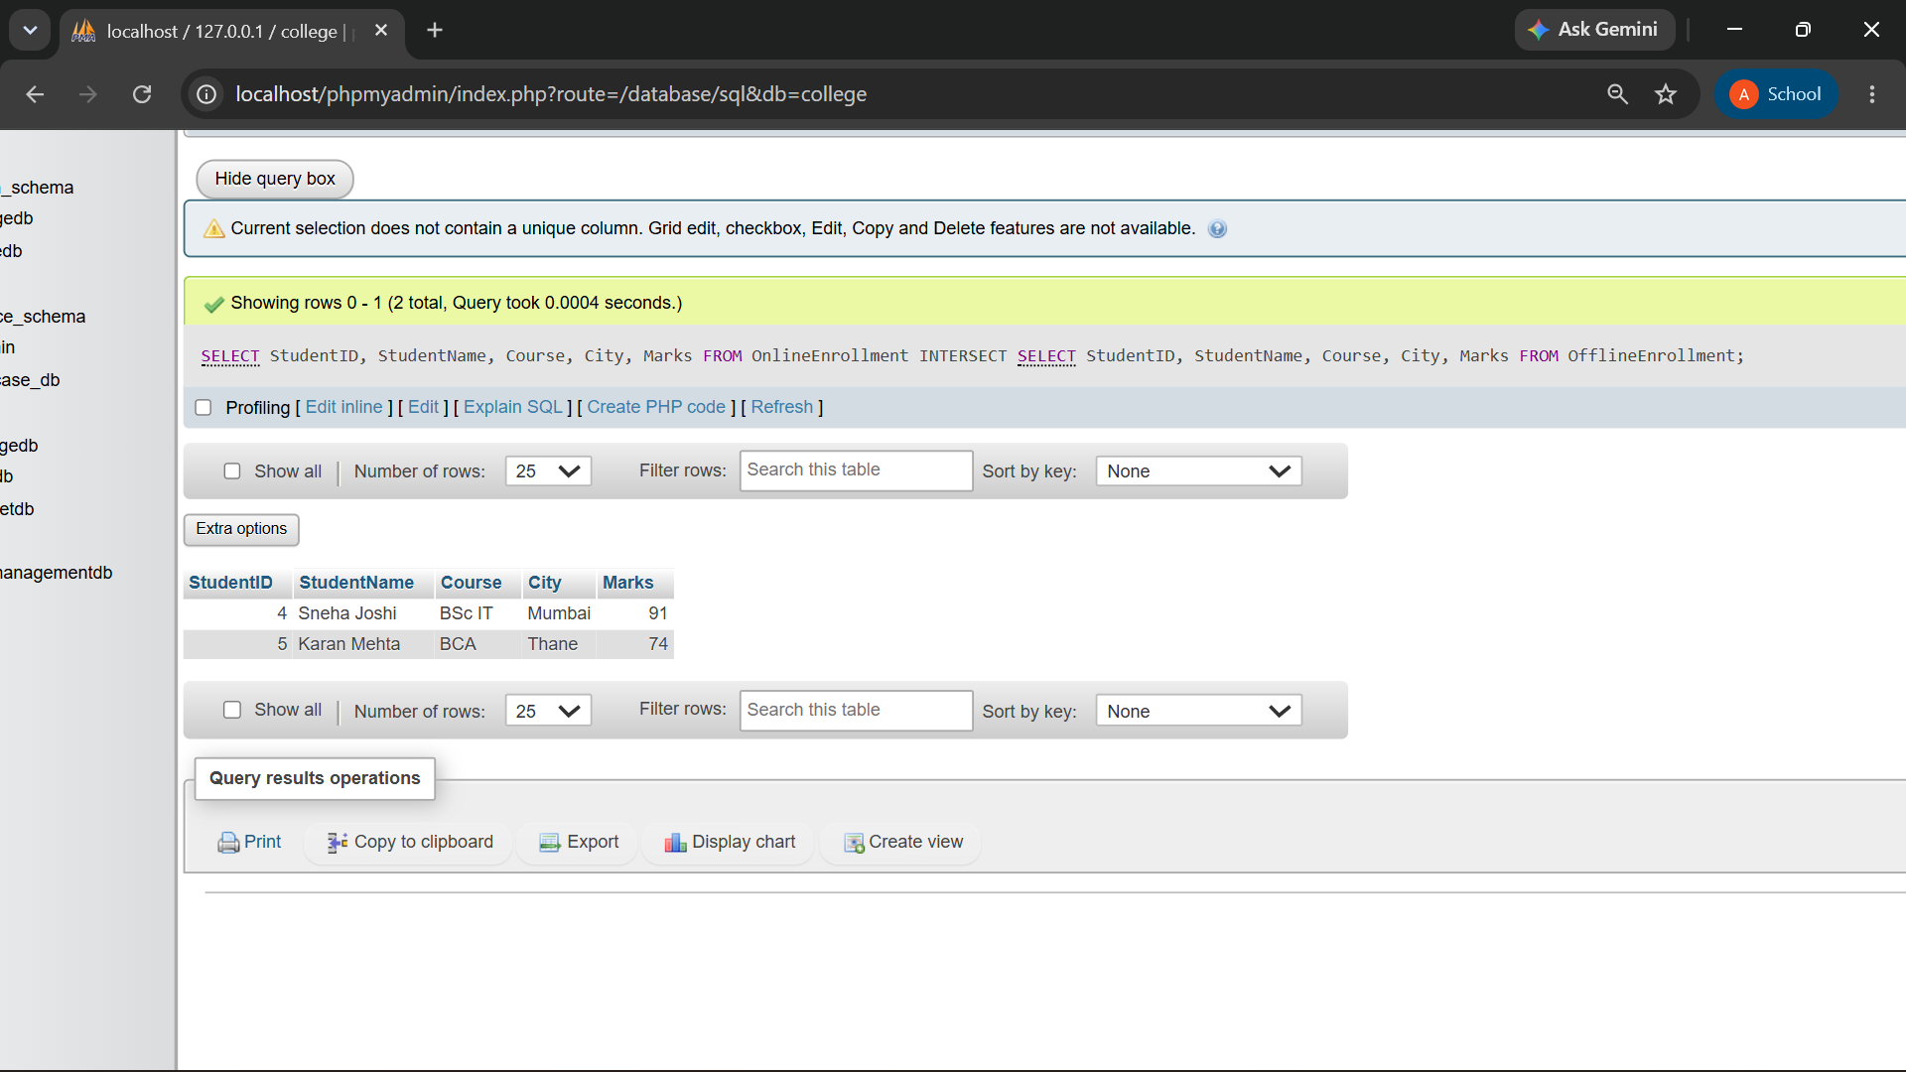
The result contains the records common to both enrollment sources.

Q5) Write a MySQL query using EXCEPT to display students who are present only in the online enrollment table.
The output should contain:
Column
StudentID
StudentName
Course
City
Marks

QUERY:
SELECT StudentID, StudentName, Course, City, Marks FROM OnlineEnrollment
EXCEPT
(SELECT StudentID, StudentName, Course, City, Marks FROM OfflineEnrollment);

OUTPUT:

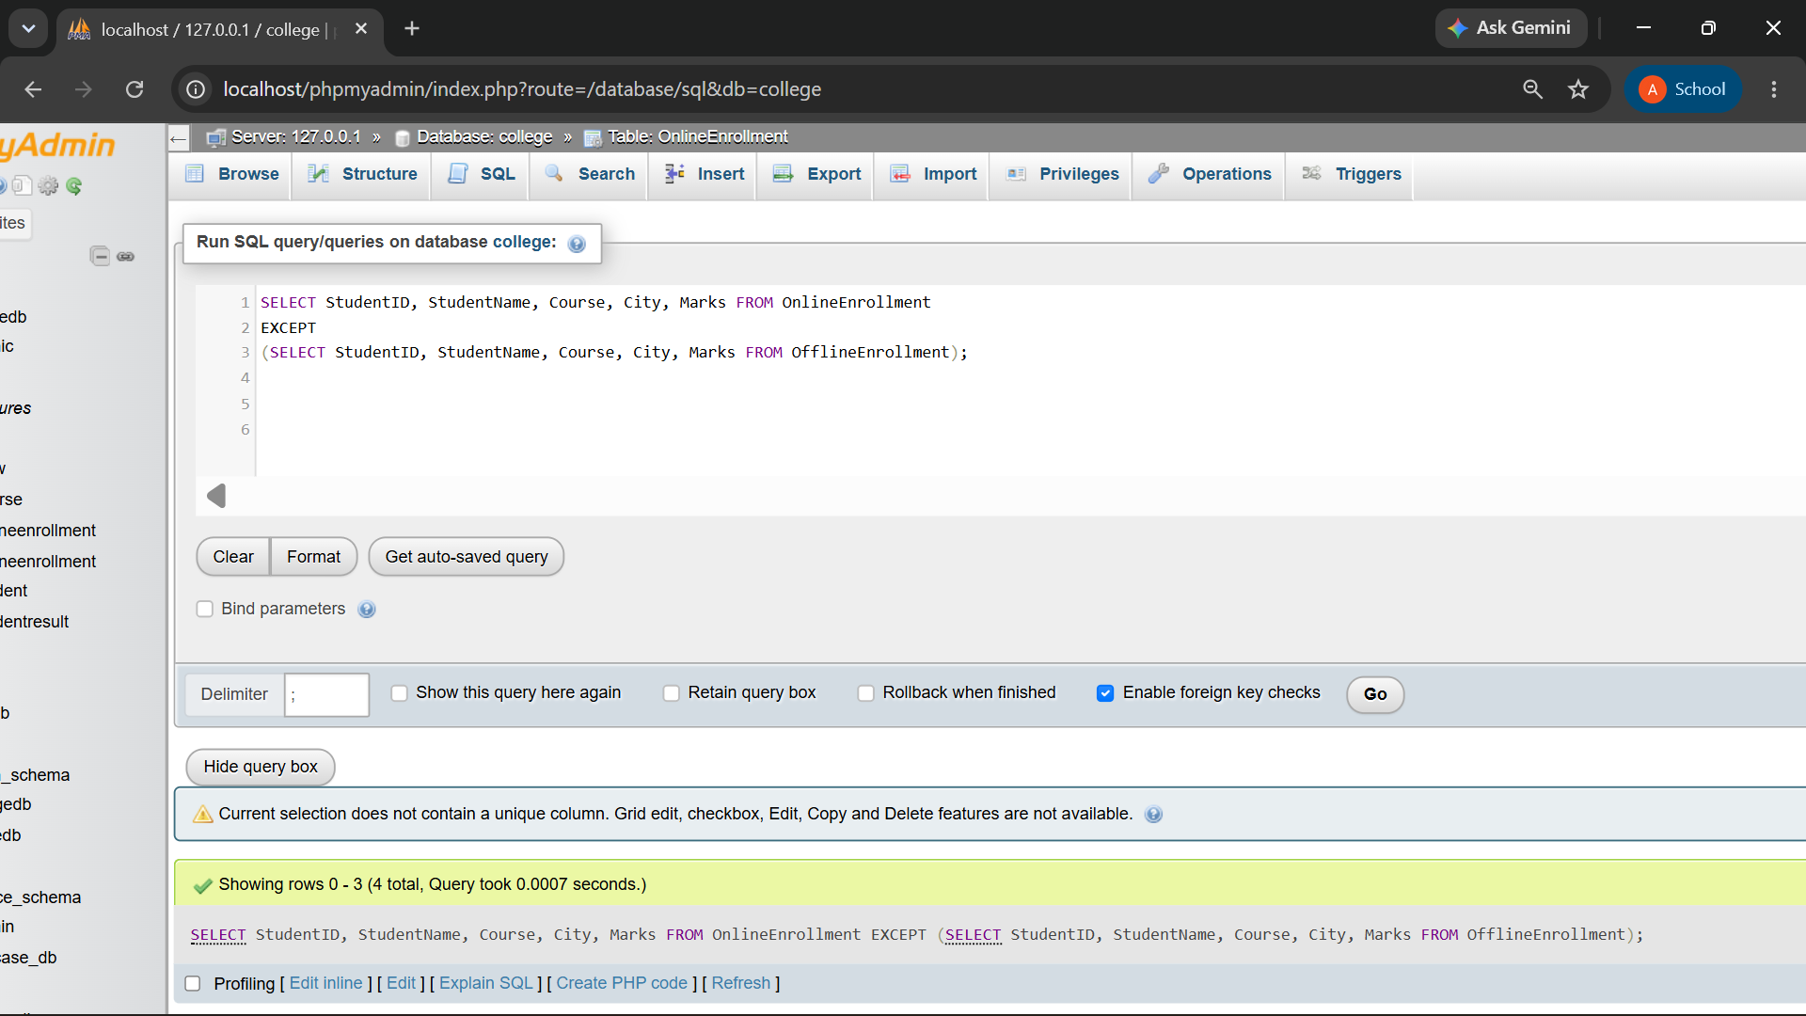
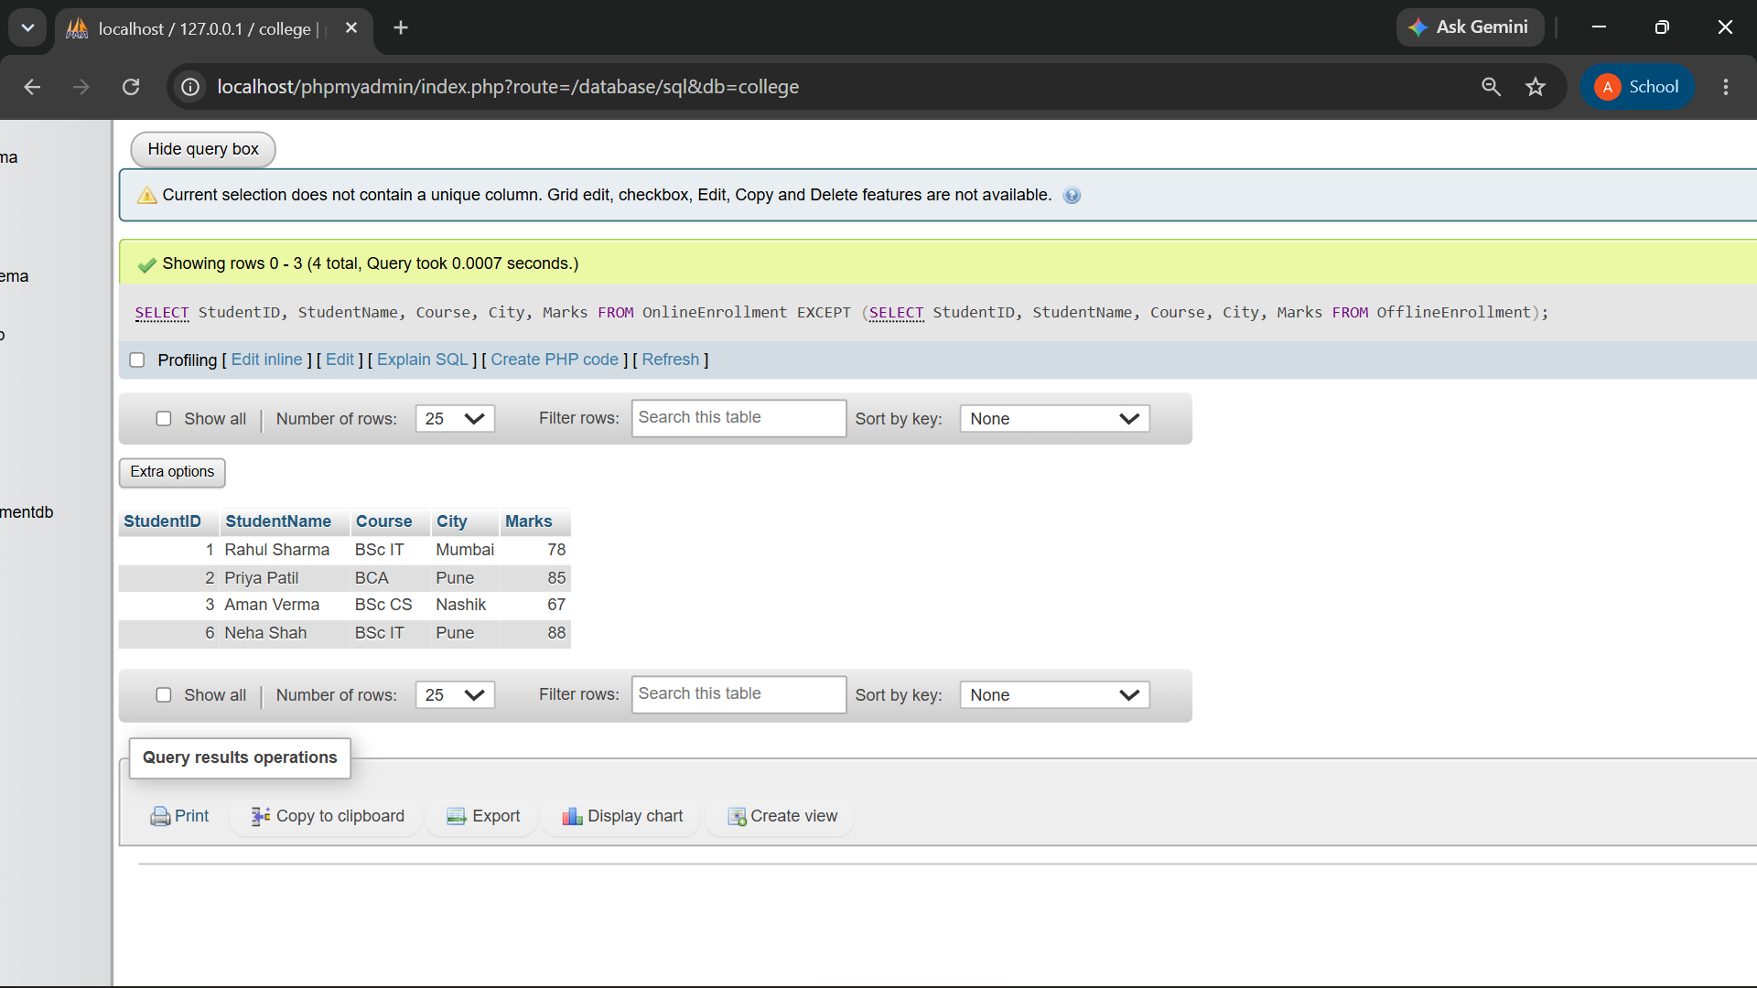
Q6) Write a MySQL query to display high-scoring students from both tables.
The query should:

Requirement
Select students with marks greater than or equal to 85
Use UNION to combine both tables
Display StudentID, StudentName, Course, and Marks
Sort the final output by Marks in descending order

QUERY:
SELECT StudentID, StudentName, Course, Marks FROM OnlineEnrollment
WHERE Marks >= 85 UNION
SELECT StudentID, StudentName, Course, Marks FROM OfflineEnrollment
WHERE Marks >= 85 ORDER BY Marks DESC;

OUTPUT:

